**TCHAIKOVSKY—**Mvt IV: X – 426

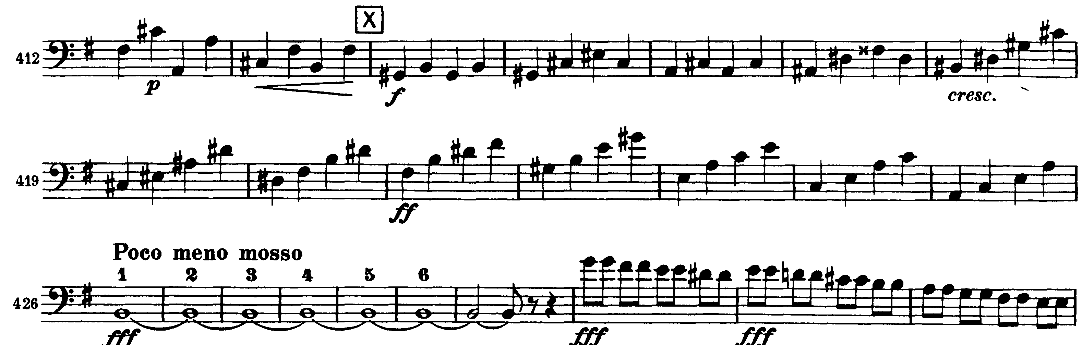

Mvt IV: Presto – Dd

